
MIZAN–TEPI UNIVERSITY
TEPI CAMPUS
SCHOOL OF COMPUTING AND INFORMATICS
DEPARTMENT OF INFORMATION SYSTEM
INDIVIDUAL ASSIGNMENT OF COMPUTER ORGANAZITION
AND ARCHITICTURE
COURSE CODE : INSY2054
SECTION A

NAME ID
GEBRIE ADANE 7832/17 Submi

Submited To:ms……Stige
Submition Date:27/6/2018 E.C

Table content page

- Introduction To computer Architecture……………………………………………………………………………
- Von Neumann Architecture Overview…………………………………………………………………………
- Components Of Von Neumann Architecture……………………………………………………………………….
- Working Principle Of Von Neumann Architecture…………………………………………………………………
- Advantages And Dis advantages Of Von Neumann And Harvard Architecture……………………
- Harvard Architecture Of Overview……………………………………………………………………………………….
- Components Of Harvard Architecture………………………………………………………………………………….
- Comparison Between Von………………………………………………………………………………………………..
- Conclusion………………………………………………………………………………………………………………………..

Introduction
- Von Neumann Architecture: Proposed in 1945
- it uses a single memory to store both data and instructions. It has one bus system for transferring data and instructions. It is simple and cost-effective but slower due to the Von Neumann bottleneck where data and instructions compete for the same memory. • Harvard Architecture: Uses separate memory for data and instructions with separate buses. This allows simultaneous access to data and instructions, making it faster and more efficient, especially in real-time systems. •
- Main Differences: Von Neumann uses single memory and single bus; Harvard uses separate memory and separate buses. Von Neumann is simpler and cheaper; Harvard is faster but more complex and expensive

Difference Between Von Neumann and Harvard Architecture
- Von Neumann and Harvard Architecture are the two models in the fields of computer architectureIt is essential to understanding the characteristics of these architecture Von Neumann architecture uses a single shared memory system Harvard architecture uses separate memories for data and instructions.architecture has advantages, disadvantages, and real-world uses.
Von Neumann Architecture – Definition
- Proposed by John Von Neumann in 1945.
  - Uses one memory for both data and program instructions.
  - Uses a single bus to transfer data and instructions.
  - Common in early computers and basic system designs. It Also Uses a single Bus System To Transfer Data And Instructions Between The CPU And Memory.
  - It Also Uses a single Bus System To Transfer Data And Instructions Between The CPU And Memory. It Also Uses a single Bus System To Transfer Data And Instructions Between The CPU And Memory.
Von Neumann of Working Principle
- Step 1: CPU fetches instruction from memory.
  - Step 2: Instruction is decoded by Control Unit.
  - Step 3: ALU executes the instruction.
Data and instruction share the same memory pathway.
  - Von Neumann of Advantages
1. Simple and Easy Design
  - Uses a single memory for both data and instructions.
  - Reduces hardware complexity compared to other architectures.
  - Easier for engineers to design and implement.
  - Suitable for beginners to understand computer organization
2. Cost-Effective Implementation
- Single memory unit reduces hardware requirements.
  - Fewer components mean lower manufacturing costs.
  - Shared data and instruction bus reduces wiring complexity.
  - Ideal for low-budget and small-scale systems.
- 3. Flexible Memory Usage
- Same memory space stores both programs and data.
  - Memory can be allocated dynamically.
  - Allows efficient use of available memory.
  - Programs can modify data easily within the same memory.
- 4. Easier Programming Model
- Linear execution model (fetch-decode-execute cycle).
  - Sequential instruction processing simplifies debugging.
  - Easy to understand for students and programmers.
  - Supports stored-program concept.
- 5. Efficient Use of Resources
- Shared bus system minimizes redundant hardware.
  - Better utilization of CPU and memory resources.
  - No need for separate memory modules.
  - Efficient for general-purpose computing tasks.
Von Neumann Architecture Diagram
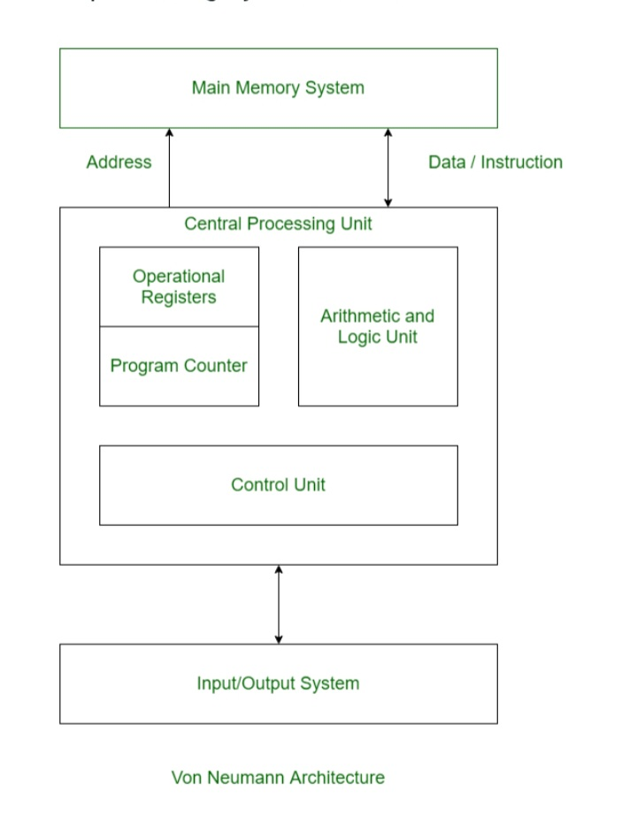
Figure 1

Components of Von Neumann Architecture

Central Processing Unit (CPU)
The CPU is the brain of the computer, responsible for executing instructions and handling data transfer. It consists of several key components
- Arithmetic Logic Unit (ALU): The ALU performs mathematical and logical operations on data.
- Registers: Registers are small, high-speed memory locations that store data temporarily while it is being processed.
- Control Unit: The control unit manages the flow of data between different parts of the system and coordinates the execution of instructions.

Memory (RAM)
The memory, or Random Access Memory (RAM), is a volatile storage technology that loses its contents when power is turned off. RAM provides fast access to data and program instructions, allowing the CPU to execute instructions efficiently.

Input/Output Devices
Input/Output devices enable users to interact with the computer and exchange data with external systems. Examples of I/O devices include keyboards, displays, printers, and network interfaces.
Von Neumann OF Disadvantages
- Single bus causes bottleneck problem.
  - CPU cannot access data and instruction simultaneously.
  - Slower performance compared to Harvard.
  - Heavy memory traffic reduces efficiency.
  - Memory corruption the data and instruction reside in the same memory.
  - There is a temptation of one erasing the other there by producing system faults.
- Single bus causes bottleneck problem.
  - CPU cannot access data and instruction simultaneously.
  - Slower performance compared to Harvard.
  - Heavy memory traffic reduces efficiency.
  - Memory corruption the data and instruction reside in the same memory.
  - There is a temptation of one erasing the other there by producing system faults.
- Harvard Architecture
- Harvard architecture is a computer design model where program instructions and data are stored in separate memory units that are accessed through independent buses. This separation allows the processor to fetch instructions and access data simultaneously, which helps avoid the bottleneck present in traditional Von Neumann systems.
- Eliminates the Von Neumann bottleneck.
- Faster and predictable performance (suitable for real-time systems).
- Parallel access to both instructions and data.

Working Principle
In Harvard Architecture, fetching an instruction from instruction memory and reading/writing data from/to data memory happen at the same time without waiting for one to finish. Separate buses prevent the bottleneck that occurs when data and instructions share a path. For example, while an instruction is being executed, the next instruction can be fetched simultaneously, speeding up processing.

Components of Harvard Architecture
Harvard architecture is designed with specific components that handle instruction execution, control, and data communication.
- Arithmetic and Logic Unit: The arithmetic logic unit is part of the CPU that operates all the calculations needed. It performs addition, subtraction
- Control Unit: The Control Unit is the part of the CPU that operates all processor control signals. It controls the input and output devices and also controls the movement of instructions and data within the system.

: Input devices are used to read data into main memory with the help of CPU input instruction. The information from a computer as output is given through Output devices. The computer gives the results of computation with the help of output device

Buses
Buses are used as signal pathways. In Harvard architecture, there are separate buses for both instruction and data. Types of Buses:
- Data Bus: It carries data among the main memory system, processor, and I/O devices.
- Data Address Bus: It carries the address of data from the processor to the main memory system.
- Instruction Bus: It carries instructions among the main memory system, processor, and I/O devices.
- Instruction Address Bus: It carries the address of instructions from the processor to the main memory system.

Application of Harvard Architecture
Harvard architecture is a type of computer design where the memory for instructions and data are kept separate. Here are the some applications:
Digital Signal Processors (DSPs):
- Audio and video processing, telecommunications, radar systems, and image processing.
- Texas Instruments TMS320 for hearing aids.
Microcontrollers (MCUs):
- Embedded systems in consumer electronics, automotive systems, IoT devices, and industrial automation.
- PIC in automotive ABS
Network Processors:
- Routers, switches, and network security appliances.
- Broadcom StrataXGS
Automotive Systems:
- the Harvard Architecture: Advantages and Disadvantages
- Advantages of Harvard ArchitectureThe Harvard architecture offers several advantages over other types of computer architectures. One of the main advantages is its ability to execute instructions and fetch data simultaneously. In a Harvard architecture, the instruction memory and data memory are separate, which means that the processor can access instructions and data at the same time. This parallelism allows for faster execution of programs and improved performance.
Another advantage of the Harvard architecture is its ability to provide a more secure system. By separating the instruction and data memory, the Harvard architecture can prevent certain types of security vulnerabilities, such as buffer overflow attacks. In a Harvard architecture, the processor cannot execute data as instructions, reducing the risk of malicious code execution
- The Harvard architecture also offers better scalability and modularity. With separate instruction and data memories, it is easier to expand and upgrade the memory system without affecting the overall system performance. This modularity makes the Harvard architecture suitable for a wide range of applications, from small embedded systems to large-scale supercomputers.
- The Harvard architecture also offers better scalability and modularity. With separate instruction and data memories, it is easier to expand and upgrade the memory system without affecting the overall system performance. This modularity makes the Harvard architecture suitable for a wide range of applications, from small embedded systems to large-scale supercomputers.
- The Harvard architecture also offers better scalability and modularity. With separate instruction and data memories, it is easier to expand and upgrade the memory system without affecting the overall system performance. This modularity makes the Harvard architecture suitable for a wide range of applications, from small embedded systems to large-scale supercomputers.
Advantages of Harvard Architecture
- Faster Instruction Fetch: Since the instruction memory is separate from the data memory, the processor can fetch instructions and data simultaneously. This reduces the time required for instruction fetch, leading to improved performance.
- Improved Performance: The simultaneous access to instruction and data memory allows for parallel processing, which can significantly enhance the performance of certain types of applications, such as multimedia processing, signal processing, and real-time systems.
- Enhanced Security: The separation of instruction and data memory spaces provides an additional layer of security. It prevents certain types of attacks, such as buffer overflow attacks, where malicious code can overwrite data with instructions.
- Simplified Memory Management: The separation of memory spaces simplifies the memory management process. It eliminates the need for complex memory management techniques, such as virtual memory, as each memory space can be managed independently.
- Efficient Code Execution: The Harvard architecture allows for efficient code execution by providing separate buses for instruction and data. This means that the processor can simultaneously fetch an instruction and access data from memory, resulting in faster execution times.
- Improved Energy Efficiency: The separation of instruction and data memory reduces the power consumption of the processor. By accessing instructions and data simultaneously, the processor can minimize the number of memory accesses, which in turn reduces energy consumption.
- Scalability: The Harvard architecture is highly scalable, making it suitable for a wide range of applications. It can be easily expanded by adding more instruction and data memory, allowing for increased processing power and storage capacity.
- Support for Different Instruction Sets: The Harvard architecture can support multiple instruction sets, making it versatile and adaptable to different computing requirements. This flexibility allows for the execution of various types of applications, from simple tasks to complex computations.
- Reliability: The separation of instruction and data memory spaces enhances the reliability of the system. If a memory error occurs in one memory space, it does not affect the other, minimizing the impact on the overall system functionality.

Disadvantages of Harvard Architecture
- Despite its advantages, the Harvard architecture also has some disadvantages. One of the main disadvantages is the increased complexity of the system. With separate instruction and data memories, the processor needs to have separate buses and control mechanisms for accessing these memories. This complexity can make the design and implementation of a Harvard architecture more challenging and expensive.
- Another disadvantage of the Harvard architecture is its limited flexibility. In a Harvard architecture, the size of the instruction memory and data memory is fixed and cannot be easily changed. This limitation can be problematic in certain applications that require dynamic memory allocation and management.
- Programming Challenges: Programming for the Harvard architecture can be more challenging compared to the von Neumann architecture. Developers need to be aware of the separate memory spaces and carefully manage the data and instruction accesses.
- Compatibility Issues: The Harvard architecture is not compatible with all types of software and programming languages. Some software and programming languages assume a von Neumann architecture, which can lead to compatibility issues when used with a Harvard architecture-based system.
- Limited Flexibility: The Harvard architecture is designed to optimize the performance of specific types of applications, such as embedded systems and digital signal processing. However, it may not be as flexible as the von Neumann architecture in handling general-purpose computing tasks. The separation of memory spaces and dedicated data and instruction paths may limit the versatility of the system.
- Increased Power Consumption: The Harvard architecture typically requires more power compared to the von Neumann architecture. This is due to the need for separate memory spaces and dedicated data and instruction paths. The increased power consumption can be a concern in battery-powered devices or systems with strict power constraints.
- Higher Cost: The additional hardware components and mechanisms required for the Harvard architecture can contribute to higher system costs. This can be a significant factor, especially in cost-sensitive applications or when scaling up the system for larger memory capacities.
- Harvard Architecture Diagram

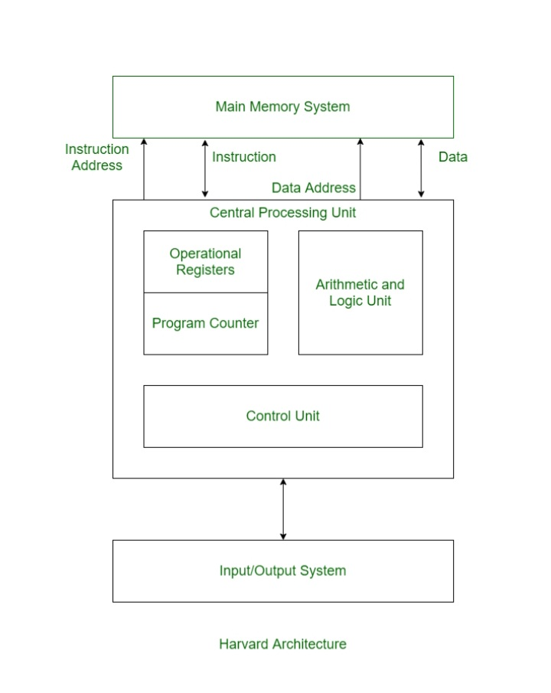

Figure 2

Comparison between Von Neumann and Harvard
Architecture 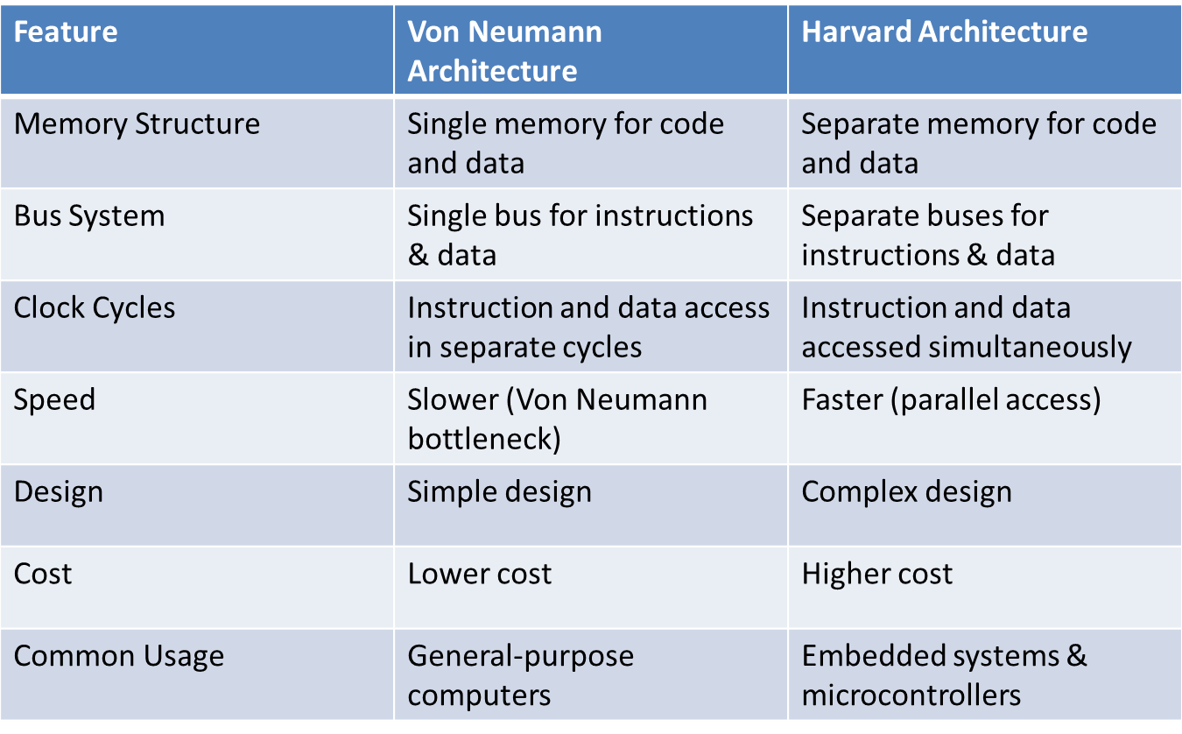

Conclusion
Von Neumann andHarvard areboth known fortheircontributions to the field of computer architecture. They are the antithesis of one another in every way. When compared to theVon Neumann, theHarvard computers necessitated morestorage space but weresignificantly faster. TheVon Neumann algorithm is straightforward and makes useof thesameprocessing unit for both the instructions and the programs, whereas the Harvard algorithm is more complicated and uses separate processing units for each type of data. Every element of the Von Neumann Architecture is a direct contrast to the style of Harvard ArchitectureIn Summary Both Von Neumann And Harvard Architecture Offer Distinct Pathways For A Computer System Design.Von Neumann architecture is simple and economical.Harvard architecture provides higher speed performance.Modern computers use Modified Harvard architecture.Understanding both improves system design knowledge. Von Neumann architecture offers simplicity and flexibility.
  - Cost-effective and easy to implement.
  - Supports the stored-program concept.
  - Widely used in computer science education.
  - Despite limitations, it remains historically important.

